Use Case Documentation for Figma Slides

# Introduction

This document provides use case details for three domains: Education, Healthcare, and E-commerce. Each domain is represented with 5 Figma slides (to be inserted later). The document also includes research on 5 existing websites per domain to provide real-world references.

# 1. Education Domain

Use Case Description:

The Education domain focuses on providing students, teachers, and administrators with access to online learning platforms, courses, assessments, and collaboration tools. The system supports functions like course enrollment, online classes, assessments, and results management.

## Use Cases:

* - Student registers and logs into the platform.
* - Students enroll in courses and access learning materials.
* - Teachers upload and manage course content.
* - Students take assessments and view results.
* - Admin manages users, courses, and system reports.

## Research Websites (Education):

* - Coursera (www.coursera.org)
* - edX (www.edx.org)
* - Khan Academy (www.khanacademy.org)
* - Udemy (www.udemy.com)
* 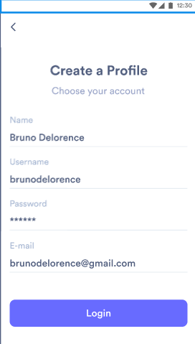) 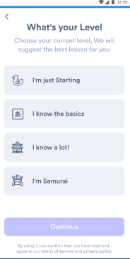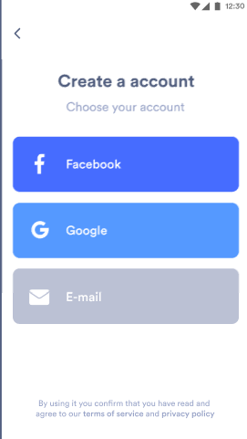

# 2. Healthcare Domain

Use Case Description:

The Healthcare domain focuses on digital health services where patients, doctors, and administrators can interact via an online platform. The system supports doctor search, booking appointments, viewing medical records, and managing prescriptions.

## Use Cases:

* - Patient searches for a doctor.
* - Patient books and manages appointments.
* - Doctor provides prescriptions and updates medical records.
* - Patient views health records and makes payments.
* - Admin manages doctors, patients, and generates reports.

## Research Websites (Healthcare):

* - Practo (www.practo.com)
* - Zocdoc (www.zocdoc.com)
* - 1mg (www.1mg.com)
* - WebMD (www.webmd.com)
* - Healthline ([www.healthline.com](http://www.healthline.com))

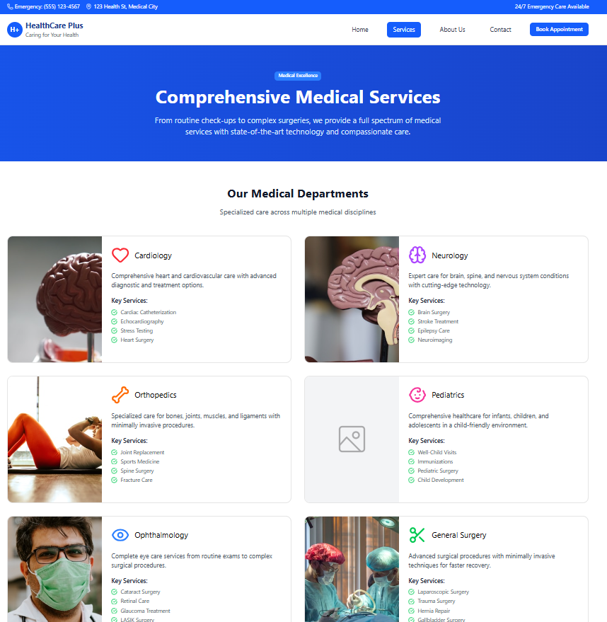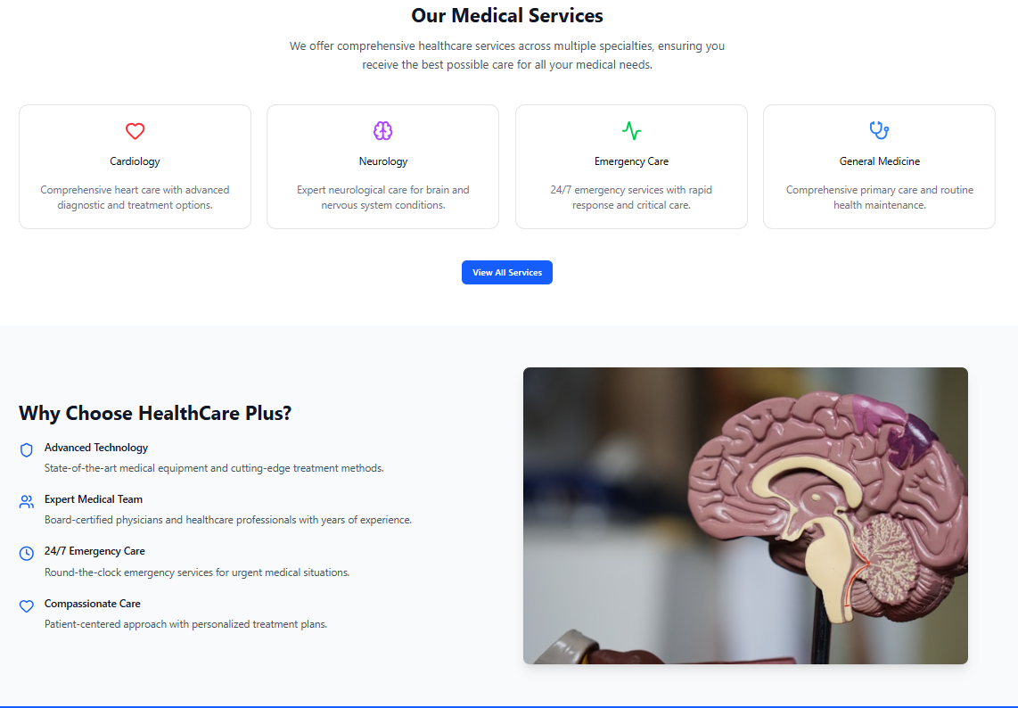

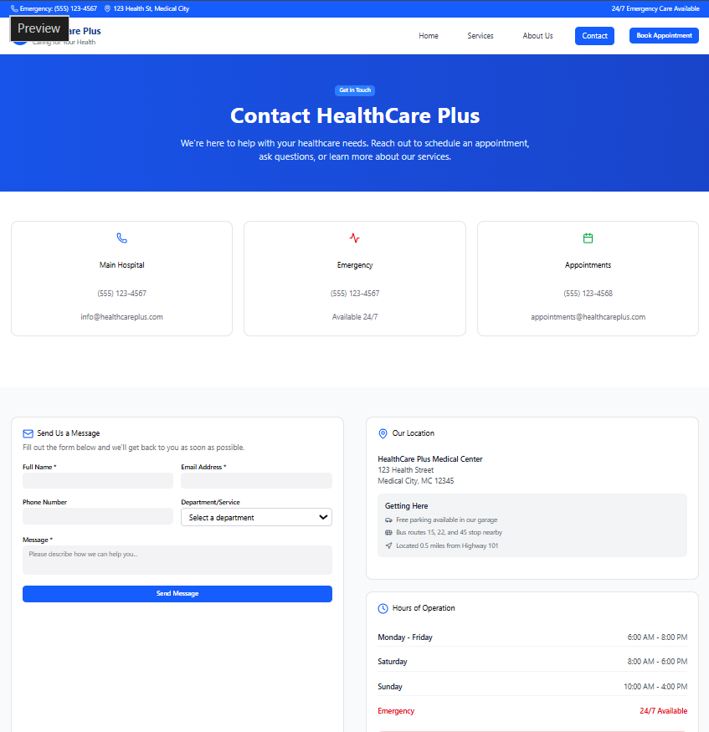

# 3. E-commerce Domain

Use Case Description:

The E-commerce domain focuses on providing customers with online shopping services, where they can browse products, add items to the cart, make payments, and track orders. Sellers and administrators manage inventory, process payments, and generate reports.

## Use Cases:

* - Customer browses products and adds them to the cart.
* - Customer registers, logs in, and makes payments.
* - Seller manages product listings and inventory.
* - Customer tracks order status and delivery.
* - Admin generates sales reports and manages users.

## Research Websites (E-commerce):

* - Amazon (www.amazon.com)
* - Flipkart (www.flipkart.com)
* - eBay (www.ebay.com)
* 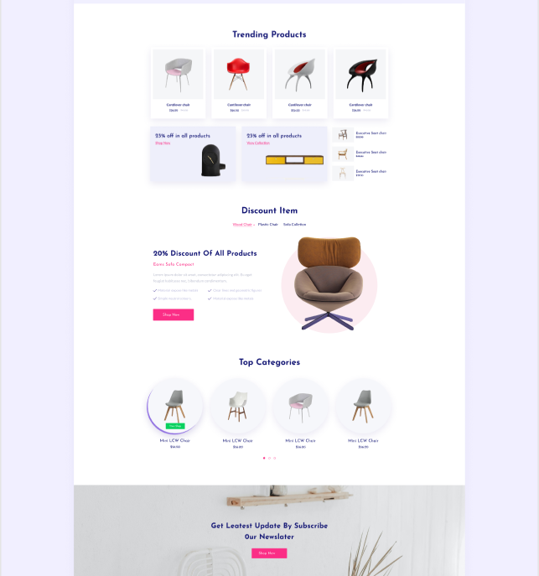- Alibaba (www.alibaba.com)
* 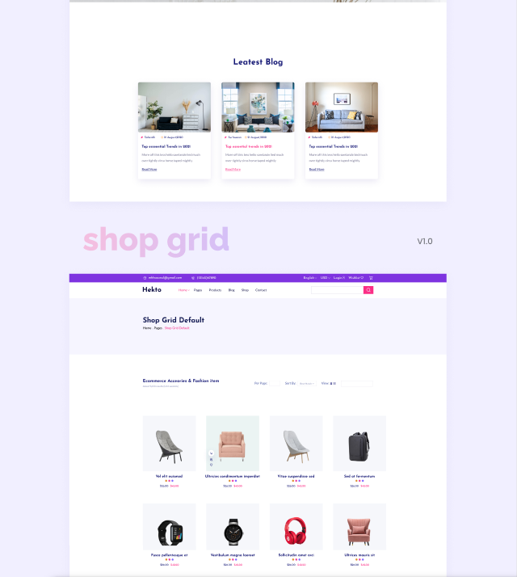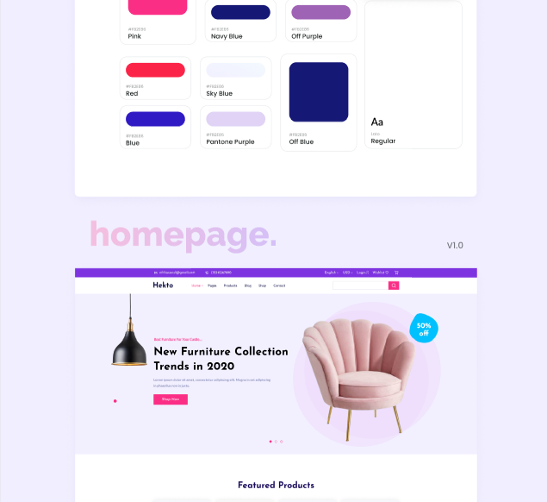- Myntra (www.myntra.com)

